ELDT 6110
Instructional Design Project: Student Advising Training
Whitney Manzo
Fall 2022

Table of Contents
Section 1: Analysis …….………………………………………………………………… pg. 3
A. Needs Analysis
B. Learner Analysis
C. Contextual Analysis
D. Unit Goals
E. Task Analysis
Section 2: Design …………………..…………………………………………………… pg. 10
A. Instructional Objectives
B. Sequencing
C. Instructional Message
D. Strategies Table
E. Text Design
F. Multimedia Design
Section 3: Development ………………………………………………………………… pg. 16
A. Instructional Materials
B. Sample Instructional Materials
C. Delivery Methodology
Section 4: Implementation ……………………………………………………………… pg. 24
A. Unit Overview
B. Pre-Workshop Planning
C. Instructional Environment, Equipment, and Materials
D. Assessment of Learning
Section 5: Evaluation …………………………………………………………………… pg. 31
A. Evaluation Process
B. Alignment of Unit Goals
C. Formative Evaluation
References ………………………………………………………………………………. pg. 37

About this Guide
This guide outlines the instructional plan for Student Advising Training at the College. It contains five sections, each of which covers a different part of the ADDIE model for instructional design. This training was created for the College and should not be used for any other purposes.
Section 1: Analysis
Summary of the Problem: Faculty new to a small college in the southeast (hereinafter the College) are tasked with advising students after their first year on the job, but they are not trained in student advising. Experienced faculty understand parts of student advising, but new advising demands have arisen that they have less experience in.
Needs Analysis
- Felt needs: a survey of all faculty past their first year at the College discovered that 60% of the faculty felt unprepared for student advising conversations. New faculty and experienced faculty felt unprepared in different ways:
  - The new faculty said that they did not know how to determine which classes a student has already taken vs. needs to take in the advising software. They also need help with finding classes in the online Course Catalog that satisfy certain General Education credits (for example, finding all of the classes being offered in a semester that would count towards the Gen Ed requirement of Ethical Reasoning).
  - The experienced faculty said that they did not know how to give students advice on time management and study skills. They also reported that they were increasingly getting questions from students about resources on campus but did not know how to answer them.
- Expressed needs: many faculty indicated on the aforementioned survey that they would be interested in training on student advising. There have also been complaints filed by students who were mistakenly advised, causing their graduation to be delayed, and the Office of Retention has asked the administration to divert resources to the creation of an online student advising training program that can hopefully stop mistakes in advising, thereby ending the student complaints.
- Anticipated or future needs: the College anticipates more employee turnover, as higher education has become another industry where changing jobs is a regular occurrence. Therefore, development of an online student advising training program is preferable to creation of an in-person training program because the College would only have to pay for the former once and it can be used until the advising software is changed.
- Actual performance vs. optimal performance:
  - Performance gap analysis

Current Learner Performance | Optimal Learner Performance
0% of the new faculty understand how to use the advising software to evaluate student progress and find classes that satisfy Gen Ed requirements | 100% of new faculty will understand how to use the advising software to evaluate student progress and find classes that satisfy Gen Ed requirements
45% of experienced faculty can identify all 7 of the campus resources for students* | 100% of all faculty will know all 7 of the campus resources for students
60% of all faculty know how to advise students on time management and study skills | 100% of all faculty will know how to advise students on time management and study skills
*The 7 campus resources for students are: the Counseling Center, the Learning Center, the DEI office, the food pantry, the Office of Career Planning, the Dean of Students office, and the StrongPoints Center
- Potential solutions
  - Create an online student advising training program that would have two parts: one part that teaches new faculty how to use the advising software (New Faculty Training) and one part that teaches all faculty about time management skills, study skills, and all 7 of the resources on campus to assist students with various issues (All Faculty Training).
  - Create in person student advising sessions- one that that teaches new faculty how to use the advising software and one that teaches all faculty about time management skills, study skills, and all 7 of the resources on campus to assist students with various issues- and deliver them at least once an academic year.
  - Ask the two full time student advisers to offer drop-in hours for faculty who need assistance with the advising software.
  - Create magnets with all 7 campus resources listed on them to assist faculty in directing students to the resources they need.

Learner Analysis

- Description of the learner group: In the first year, the learners will consist of 5 new faculty (for the New Faculty Training) and 100 experienced faculty (for the All Faculty Training). In subsequent years, the New Faculty Training learners will consist of whatever new faculty have joined that year and the All Faculty Training Learners will consist of roughly half the faculty (all faculty will be required to review the training once every 2 years).
- Demographic characteristics: Everyone in the group is highly educated, since attainment of a PhD is required for employment as a faculty member at the College. Ages range from 28 to 75. Regarding gender, the faculty are 45% men, 50% women, and 5% nonbinary. Regarding race/ethnicity, the faculty are 70% White, 10% Black, 15% Latino, and 5% Other. All of the faculty are fully fluent in English, and many of them speak additional languages.
- Motivation and attitude toward the subject: New faculty are highly motivated to learn the advising software. Motivation among experienced faculty varies, but 80% reported recognizing the importance of knowing all of the campus resources available to students, as well as time management and study skills, in order to be able to fully support their advisees.
- Pre-knowledge about the subject: New faculty have no knowledge about the advising software. Only 45% of experienced faculty can identify all 7 of the campus resources available to students, and the remainder can identify, on average, 4 of the 7. Only 60% of the faculty report that they know how to advise students on time management and study skills; the other 40% report feeling uncomfortable with the topics because they don’t feel prepared enough to help.
- Technology skills: All of the faculty know basic computer functions, like how to use an internet browser, how to use word processing software, etc. New faculty do not know how to use the campus advising software. The training modules will be housed on the campus LMS, and 85% of faculty report feeling completely comfortable with using the LMS. The remaining 15% report feeling only slightly comfortable with using the LMS.
- Impairments or disabilities: There are no known impairments or disabilities among the group of learners.

Contextual Analysis

- Orienting context: Both the new and experienced faculty have the goal of understanding student advising better, because they want to be able to fully support their students. No faculty member wants to be the reason a student has to take an extra semester to graduate because they messed up their advising, so they are motivated to learn how to do it well. They also see the utility of the training dedicated to time management and study skills, because these ideas will help them assist their struggling students even better. Additionally, they recognize the importance of knowing what is available to students on campus who have specific needs that a faculty member cannot provide (for example, mental health counseling or to experience belonging with a cultural affinity group). The training will be required as part of a faculty member’s yearly professional development requirements, so everyone will have to complete the training even if they feel they understand student advising fully. The reason for repeating the All Faculty Training every other year is to ensure that faculty are up to date with the latest campus resources, which change often.
- Instructional context: New faculty will be required to complete the New Faculty Training program each year in the week prior to the fall semester, called Professional Development and Planning Week. All faculty will be required to complete the All Faculty Training that week in the first year of using these new training materials. In subsequent years, roughly half of the faculty will be required to review the All Faculty Training, again during the designated Professional Development and Planning Week. The trainings will be completed on each faculty member’s institutional laptop, using modules housed on the campus LMS. Therefore, each faculty member can choose their own learning environment, whether they complete the training in their office, at home, or at a coffee shop.
- Transfer context: Faculty will begin using their new knowledge as soon as the semester begins and they resume seeing students. They will use their advising software knowledge at least once per semester per student, during course advising meetings. Therefore, these learners will begin transferring and applying their learning regularly.

Unit Goals

- Understand how to use advising software to see what requirements remain for a student vs. what requirements they have already completed, and how to find classes each semester that fulfill Gen Ed requirements.
- Recall all 7 of the campus resources available to students and be able to show students how to access them.
- Learn time management and study skills in order to be able to teach them to students.

Task Analysis

- Topic Analysis
  - Topic 1: Advising Software
    - How to generate a Student Progress Report, which outlines what classes a student has completed and what classes remain to be taken
    - How to try out different majors using the Student Progress Report, to help students narrow down their major options
    - How to search the Course Catalog for classes that are being offered in a given semester that fulfill certain Gen Ed requirements
  - Topic 2: Campus Resources
    - List of 7 resources that are available to students and what each of them offers:
      - the Counseling Center: confidential resource for students who need counseling
      - the Learning Center: hosts tutoring services in various subjects
      - the DEI office: coordinates cultural affinity groups; hosts cultural holiday celebrations; educates the community on issues related to diversity, equity, and inclusion
      - the food pantry: provides food to those who need it
      - the Office of Career Planning: helps with resume writing, head shots, personal statements for grad school, mock interviews; shares job advertisements with the campus
      - the Dean of Students office: a place to make formal complaints about other students or faculty or staff; the administrator who notifies faculty when students are seriously ill or have a loss in their family
      - the StrongPoints Center: how to use their Strengths (determined during freshman year using the Clifton StrengthsFinder) in their classes and work; how to choose a major that fits their Strengths
    - How to direct a student to each of the campus resources
  - Topic 3: Time Management and Study Skills
    - Time management skills
      - Different approaches to calendars/time tracking
      - Removing distractions
      - Understanding one’s personal productivity clock and how to use it to one’s advantage
      - How to prioritize
      - Helpful apps
    - Study skills
      - Effective reading techniques
      - Different note-taking strategies
      - Self-testing
      - Study groups
- Procedural Analysis
  - Topic 1: Advising Software
    - What does the learner do? Help a student choose classes to take each semester.
    - What does the learner need to know to do this step?
      - How to determine which classes remain to be taken in a student’s Gen Ed and major requirements using the Student Progress Report.
      - How to search the Course Catalog for classes that fulfill certain requirements.
    - What cues inform the learner that there is a problem, the step is done, or a different step is needed?
      - The primary problem that could occur is if the advising software is down for maintenance purposes, because then the faculty member cannot advise the student what to take.
      - The learner will know their work is done when the student has a complete schedule for the upcoming semester that will keep them on track to graduate on time.
  - Topic 2: Campus Resources
    - What does the learner do? Direct students to the appropriate campus resource based on their individual needs.
    - What does the learner need to know to do this step?
      - What the 7 campus resources are and what each of them offers
      - Where to direct students so they can access each campus resource
    - What cues inform the learner that there is a problem, the step is done, or a different step is needed?
      - The primary problem that could occur is if the campus resource is closed when a student needs to access them.
      - The learner will know their work is done when the student knows where to go for what they need.
  - Topic 3: Time Management and Study Skills
    - What does the learner do? Learn time management and study skills in order to be able to teach them to students.
    - What does the learner need to know to do this step?
      - Knowledge of time management skills
      - Knowledge of study skills
      - Effective teaching methods
    - What cues inform the learner that there is a problem, the step is done, or a different step is needed?
      - The primary problem that could occur is if the faculty member did not fully understand the time management and/or study skills, so they are not able to convey them to their struggling students.
      - The learner will know their work is done when their students report back with their results, or the faculty member witnesses the student’s proper usage of the time management and study skills they have learned.

Section 2: Design
Instructional Objectives
- Given access to the campus advising software, the faculty member will be able to determine which classes a student needs to take to finish their requirements in order to keep 100% of students on track to graduate on time.
  - Domain: cognitive
- After memorizing the list of campus resources, the faculty member will be able to indicate to 100% of students where to go to satisfy their particular needs.
  - Domain: cognitive
- After completing the training program about time management and study skills, the faculty member will feel prepared to help 100% of students with improving their time management and study skills.
  - Domain: affective

Sequencing
My training module has two parts: the first teaches new faculty members how to use the advising software (objective 1), and the second teaches all faculty members about resources on campus and how to teach students about time management and studying (objectives 2 and 3). These parts have different sequences due to their different audiences.
Because the first objective involves students learning an entirely new task, task expertise sequencing is appropriate. Therefore, the sequence should “start with the simplest task and proceed to the more complex task” (Morrison et al., 2019, pg. 136). The latter two objectives involve learning about topics that students will have varying levels of experience in, so learning-related sequencing is appropriate. This is because learning-related sequencing takes student familiarity, development, and interest into account, as well as the difficulty of the content (Morrison et al., 2019, pg. 130).
Part I: Advising Software- 25 minutes
Sequence | Description | Time | Objective | Justification
1 | The instructor will demonstrate how to generate a Student Report by generating an example Student Report in the advising software. | 2 | 1 | This is both the simplest task and the first step required to complete the remaining steps.
2 | The students will read the example Student Report and learn what information can be gleaned from it. Specifically, the instructor will ask the students to identify missing requirements in the report. | 5 | 1 | This will give the learners practice with reading and understanding Student Reports.
3 | Once missing requirements have been identified, the instructor will demonstrate how to find classes that fulfill those requirements using the software. | 8 | 1 | The primary goal of advising is to help students find classes that will lead to graduation on time. Therefore, it is important that faculty members understand how to find these classes so they can assist students with creating good schedules that keep the students on track.
4 | Students will be provided with the advising software and directed to generate other example Student Reports. Then, they will demonstrate their new knowledge by uncovering missing requirements and finding classes that could satisfy those requirements. | 10 | 1 | This will allow the instructor to determine whether the first objective has been achieved. It will also allow the instructor to identify any misunderstandings in order to correct them.

Part II: Campus Resources and Study Skills- 35 minutes
Sequence | Description | Time | Objective | Justification
1 | The instructor will ask the group to list the 7 campus resources available to struggling students. If the group fails to name all 7, the instructor will complete the list. | 5 | 2 | This will allow the instructor to see which resources are familiar to the students, as well as give the students an opportunity to participate.
2 | The instructor will ask the group to describe what each resource helps students with. If the group fails to describe all 7, the instructor will complete the list. | 5 | 2 | This will allow the instructor to gauge the development level of the group regarding campus resources and correct misunderstandings as necessary. It also gives the students an opportunity to participate.
3 | The instructor will lead students through a lesson on evidence-based time management and other study skills. | 15 | 3 | This will teach the students about time management and other study skills so they may then teach that information to their own students (an identifiable prerequisite).
4 | The students will pair up and take turns role-playing a meeting between a faculty member and a student who needs assistance. | 5 | 2, 3 | This will allow students to practice teaching others about campus resources and study skills before the final assessment.
5 | The students will complete a short quiz to demonstrate their new knowledge of campus resources and study skills. | 5 | 2, 3 | This will allow the instructor to determine if the second and third objectives have been met. It will also allow the instructor to identify any misunderstandings in order to correct them.

Instructional Message
Strategy | Function | Content Structure | Learner | Task Attributes
Part 1: Overviews | The instructor will explain what the students will learn and why in order to prepare them for the learning task. | A brief vignette explaining how advising works at the College and what faculty members need to know in order to successfully engage in it. | All learners are highly educated adults (above-average IQ, older, and more mature). | This strategy helps students understand that they will need to master facts and procedures.
Part II: Pretests | This will alert the students as to what they will be learning about next. | Short and loosely structured group discussion. | All learners are highly educated adults (above-average IQ, older, and more mature). | This strategy is beneficial when the learners already have some familiarity with the instructional concepts.

Strategies Table
Part I: Advising Software- procedure
Procedure | Strategy | Initial Presentation and Generative Strategy
Generate a student report and find the missing requirements, then find classes that fulfill those requirements. | Demonstration, organization, elaboration, and practice | First, students will be encouraged to take notes as the instructor demonstrates how to generate a Student Report and read it.  Then, students will be encouraged to take notes as the instructor demonstrates how to find classes that fulfill missing requirements.  Students will then be encouraged to practice applying these concepts using the advising software.

Part II: Campus Resources and Study Skills- concepts
Concept Example | Strategy | Initial Presentation and Generative Strategy
Campus resources | Integration | Students are presented with the name, definition, and examples of campus resources to help struggling students.  Students will then be provided with a list of campus resources and asked to match them with the services they provide.
Time management and other study skills | Argumentation | Students are presented with the names, definitions, and examples of study skills.  Students will then be asked to pair up and answer questions from their peers about study skills in order to “support the learning of the concept” (Morrison et al., 2019, pg. 152).

Text Design
A few instructional materials will be created for this lesson. First, for Part I, students will receive a how-to guide that walks them through the steps required to generate a Student Report, find missing requirements in it, and find classes to fill those missing requirements in temporal sequence (Morrison et al., 2019, pg. 179). Each step will be clearly marked from each other and accompanied by a picture illustrating what the student will see on the screen when they are in that step. Next, for Part II, students will receive a list of the 7 campus resources and their contact information on a printed magnet. This will help students keep the list in an accessible location for quick reference in the future. The magnet will be clearly organized with bullet points for each resource and attractively designed with the College’s colors and logo. Finally, also for Part II, students will receive a one-page (front and back) quick guide to time management and other study skills. The guide will be organized by topic, with topics bolded and subtopics italicized for easy reading. All key words will be underlined and defined, followed by appropriate examples, to help students master these important terms. The guide will also contain a short list of additional resources for each subtopic at the end, in a smaller font than the rest of the document.
Multimedia Design
Two different powerpoints will be used in this instruction, one for each part. Each powerpoint will use a simple design template and maintain consistent font size, colors and background. Each slide with text will follow the 6x6 rule of one thought per line, with each line containing no more than 6 words and no more than 6 lines on a slide (National Conference of State Legislatures, 2017).
The first powerpoint, regarding the advising software, will have slides with descriptions of the steps to do as well as short embedded videos that demonstrate the steps needed for generating a Student Report and finding classes that meet certain requirements. Arrows and text bubbles will be used to highlight important buttons and information on each screen.
The second powerpoint, regarding campus resources and study skills, will contain one slide per campus resource (so 7 in all) that will explain what each helps with and also a picture demonstrating where to find it on campus. The pictures are representational to “provide a concrete reference for verbal information” and make the information “more meaningful to the learner” (Morrison et al., 2019, pg. 187). Following the campus resource slides will be several slides teaching the learners about time management and other study skills. These latter slides will include links to further resources in case the learners would like or need additional information.

Section 3: Development
Instructional Materials

This training is in two parts: one for the new faculty to learn how to use the College’s advising software to assist students in keeping on track to graduation, and one for all faculty to learn (or re-learn) the campus resources available to struggling students and essential study skills. Each training module will be presented in a group format and accompanied by a PowerPoint. The Part I PowerPoint explains why the advising software is important and walks learners through how to use the software. In order to reduce cognitive load, this PowerPoint proceeds from the simplest task to the most complex task (Morrison et al., 2019, pg. 215). The Part II PowerPoint briefly outlines what each of the seven campus resources can help with, and then proceeds into information on study skills. The former slides in this PowerPoint are formatted exactly the same, with the same information presented in the same places, in order to be consistent to aid learner comprehension (Morrison et al., 2019, pg. 206). The latter slides contain links to helpful videos and resources. Each of these parts of the Part II PowerPoint are prefaced by a transition slide in order to “alert the learner that the instruction is moving to a new idea” (Morrison et al., 2019, pg. 208).
Besides the PowerPoints, learners will receive a Self Service (advising software) how-to document and a magnet outlining the contact information for all seven campus resources, which they will be able to keep for easy future reference. The final instructional material for this training is a quiz, which will only be over the Part II training. This is required so that the instructor knows whether the learner has completed the training and successfully achieved the two learning objectives. (The instructor will be able to assess in person whether the learners complete the Part I training and achieve its associated learning objective.)

Sample Instructional Materials

- Powerpoint for Part I: Advising Software
- Advising software how-to guide (attached, pg. 18)
- Powerpoint for Part II: Campus Resources and Study Skills
- Campus Resources magnet
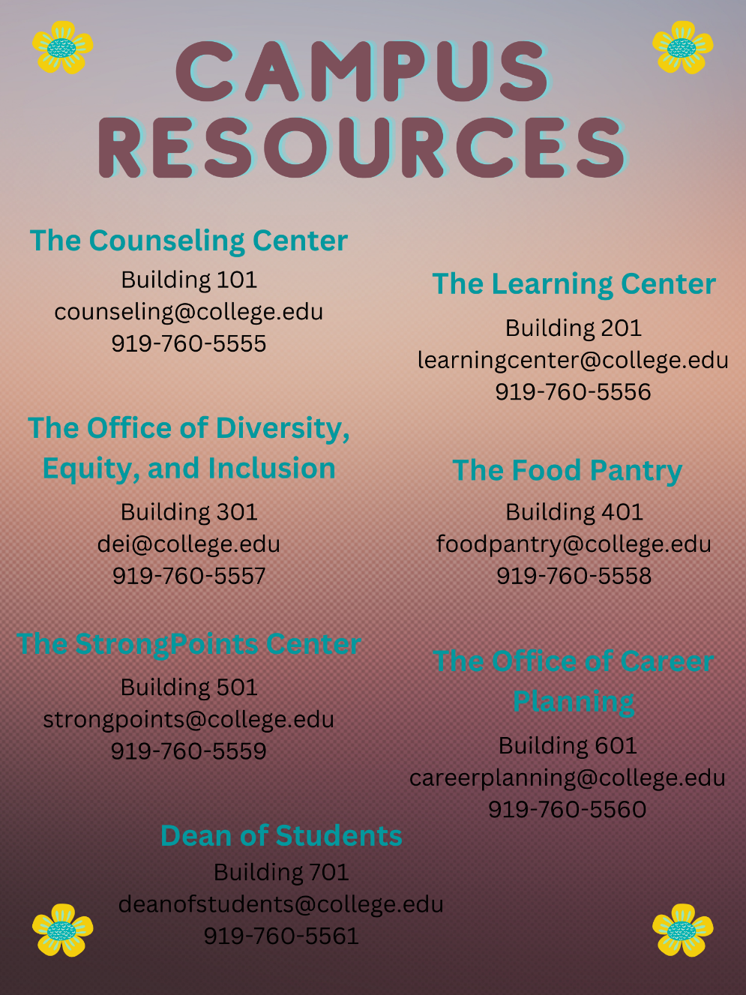

- Campus Resources and Study Skills quiz (attached, pg. 22)

Self Service How-To Guide
Note: On the step without a picture and the steps with redacted data, I decided not to include these because they would have contained sensitive student data. I’m not an administrator, so I can’t create a sample report with made-up information in it, so I did the best I could with what I have access to while protecting my students’ information. Were I creating this training for real, I would be able to use full pictures in each step.

- Open Self Service and enter in your user name and password.
- Choose Advising from the main menu.
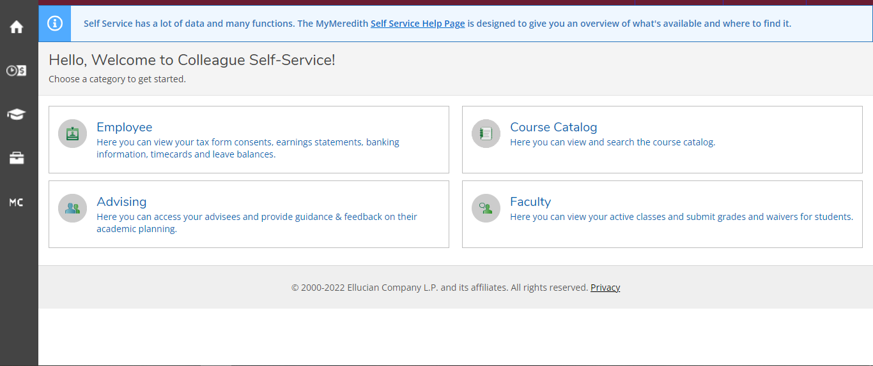
- Choose a student to advise.
- The first screen shows the student’s current schedule. Switch to the Progress tab.
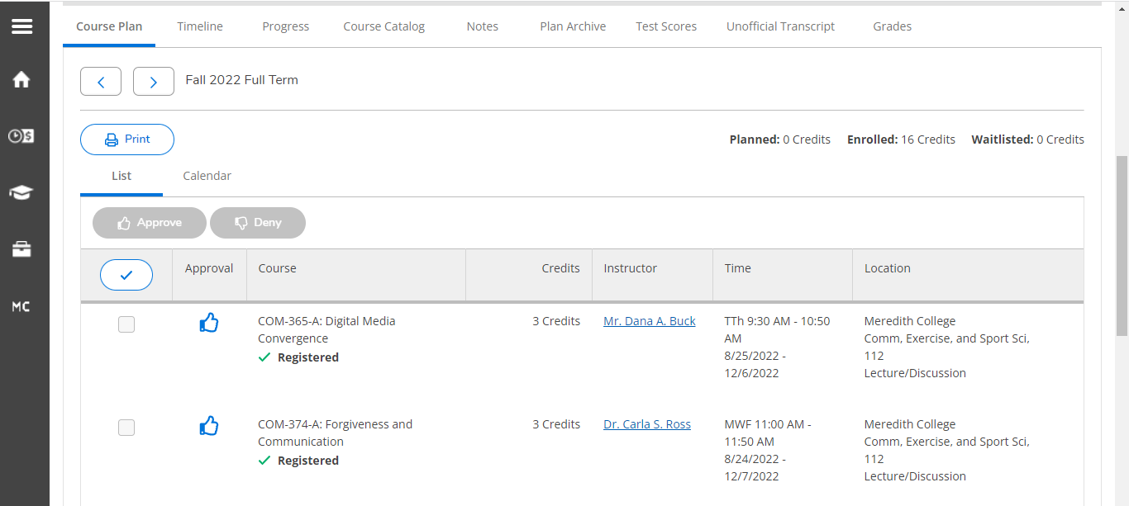
- This shows the student’s progress toward graduation. Note how many credits remain to reach a total of 124 and divide by the student’s remaining semesters to see how many credits they should take each semester to stay on track.
  - The green bar indicates completed credits.
  - The light blue bar indicates credits currently in progress.
  - The numbers to the top right of the Total Credits bar indicate how many credits are complete and planned out of 124. When calculating the credits left to graduation, deduct only the completed credits.
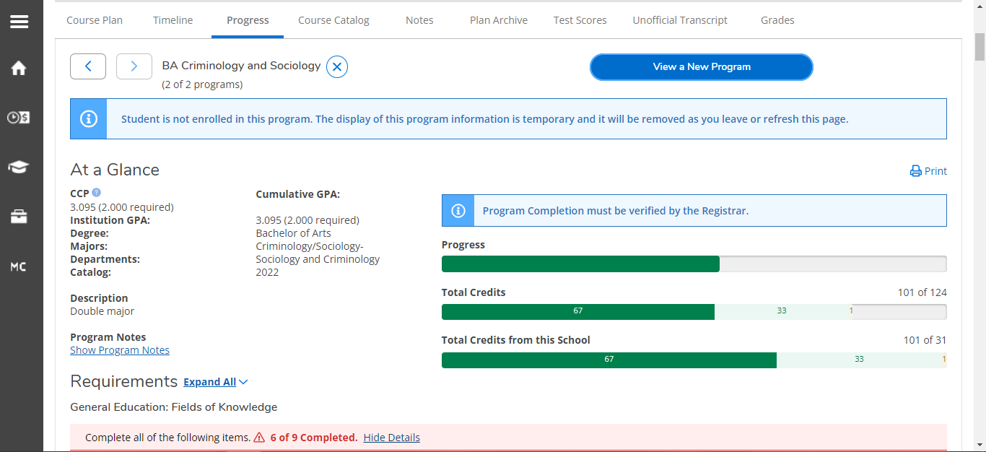
- Scroll through the report, noting where a requirement is incomplete. Incomplete requirements are denoted with an exclamation mark and bold red font, while complete requirements are denoted with a green check mark and bold green font.
  - In the picture below, the History and Laboratory Science requirements are complete while the Literature requirement is incomplete.
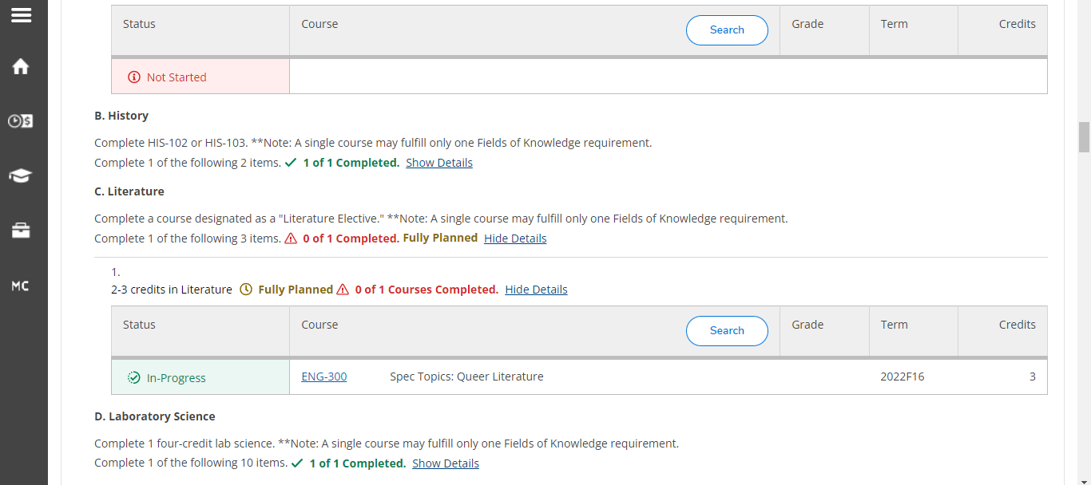
- Now, switch to the Course Catalog tab.
- In Subject Search, locate the subject that is missing in order to find classes that could fulfill incomplete requirements.
  - For example, since I know the Literature requirement is incomplete, I would search for English courses.
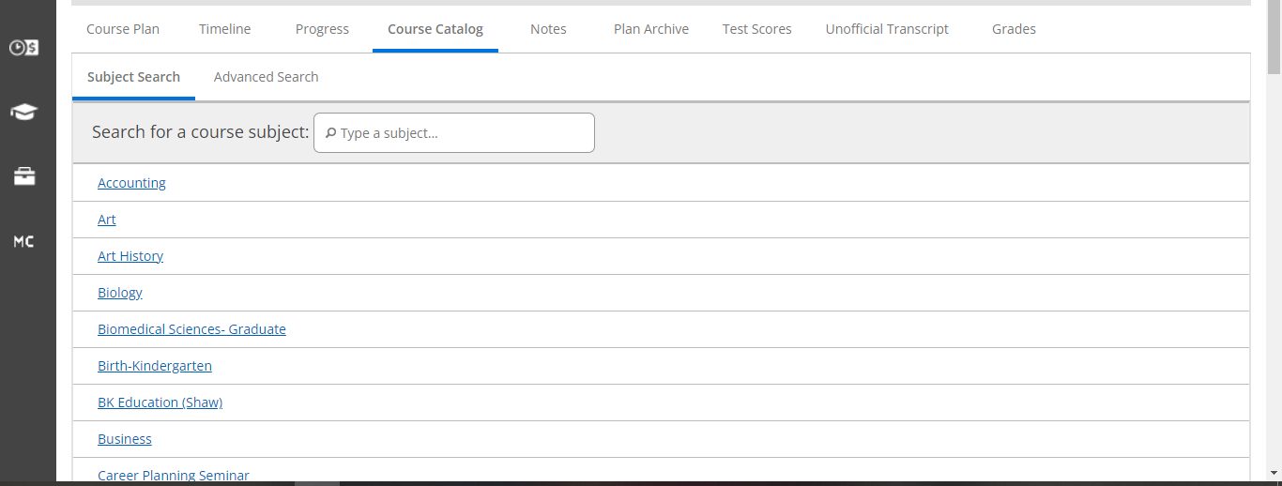
- You can use Advanced Search to find courses that fulfill certain course types, like Cultural Elective or Ethical Perspectives.
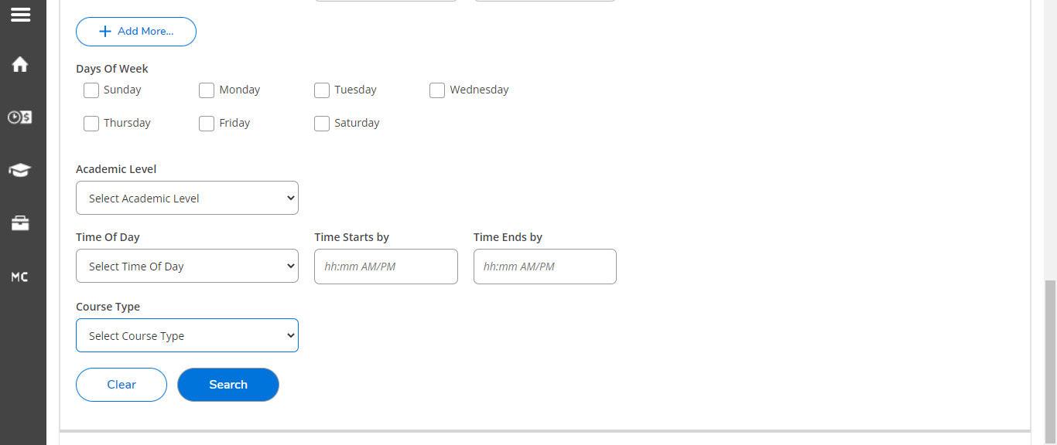

Part II Quiz

Section 1: Matching
- Counseling Center __________
- Office of Diversity, Equity, and Inclusion __________
- Office of Career Planning __________
- Learning Center __________
- StrongPoints Center __________
- Food Pantry __________
- Dean of Students __________

- This office helps students with mock interviews and resume workshops.
- This office helps students who are hungry and need a meal.
- This office helps students understand their strengths and how to apply them.
- This office helps students in mental health crisis.
- This office helps students develop cultural competency and humility.
- This office helps students who are struggling in certain subjects, like math or foreign language.
- This office helps students who need to make a complaint against a faculty member.
Section 2: Free Response
- A student needs help with time management. What are the 3 strategies you can share with them?

- Name 3 note-taking strategies that you could provide to a student.

Delivery Methodology
The Part I training will be conducted in person in a group format. This is because it is geared at new faculty to the College, which is generally a small group of 3-7 people each year, and group formats are beneficial for efficiently ensuring that the whole group receives this important information at the same time (Morrison et al., 2019, pg. 218). Ensuring that the College’s students graduate on time is of vital importance, both for the students themselves and for the College (because the 4-year graduation rate matters in school rankings). Therefore, an in-person group format is preferable to be certain that the class proceeds exactly as is needed in order to achieve the objective of every faculty member on campus helping 100% of their advisees graduate on time (Morrison et al. 2019, pg. 217). While this type of instruction is generally passive, which is a limitation, the end of the training incorporates practice with the advising software for more active learning. Additionally, learners will have a handout that they will be able to take with them that walks them through the advising software step-by-step for future reference. This handout will be provided at the beginning of the training so that the learners may take notes on them and also be active in this way.
The Part II training will also be conducted in an in-person group format. This is to enable the learners to ask lots of questions about the various services that the seven campus resources provide, because these services change fairly regularly (Morrison et al. 2019, pg. 217). While taking time for questions can slow down training, in this case allowing questions is beneficial because it is likely everyone in the training will have similar questions. Another reason this training will be in a group format is to enable practice with achieving the learning objectives of this module. In order for a faculty member to plan how they will teach this material to their students, it is important to give them practice with that instruction, and this training involves role-play practice among the participants.

Section 4: Implementation
Unit Overview
A. Background and goals of module
The College is a small, private, liberal arts college in the southeast of the United States. Its average annual enrollment is 2500 students. The majority of student advising is handled by full-time faculty. At a minimum, student advising involves assisting students with developing course schedules and ensuring that students are meeting General Education requirements, major requirements, and overall credit requirements for graduation. However, student advising increasingly includes assisting students with mental health, time management, and study struggles, as well as pointing students toward helpful campus resources like the Counseling Center, the Learning Center, the food pantry, cultural affinity groups, the DEI office, etc.
The College wants faculty prepared to advise students first and foremost so that students feel supported at the College and can be more successful in their academic pursuits.
The goals for this instructional unit are:
- Understand how to use advising software to see what requirements remain for a student vs. what requirements they have already completed, and how to find classes each semester that fulfill Gen Ed requirements.
- Recall all 7 of the campus resources available to students and be able to show students how to access them.
- Learn time management and study skills in order to be able to teach them to students.
B. Instructional needs and learner analysis
- Instructional needs: A survey of all faculty past their first year at the College discovered that 60% of the faculty felt unprepared for student advising conversations. New faculty and experienced faculty felt unprepared in different ways:
  - The new faculty said that they did not know how to determine which classes a student has already taken vs. needs to take in the advising software. They also need help with finding classes in the online Course Catalog that satisfy certain General Education credits (for example, finding all of the classes being offered in a semester that would count towards the Gen Ed requirement of Ethical Reasoning).
  - The experienced faculty said that they did not know how to give students advice on time management and study skills. They also reported that they were increasingly getting questions from students about resources on campus but did not know how to answer them.

- Learner Analysis
  - Description of the learner group: In the first year, the learners will consist of 5 new faculty (for the New Faculty Training) and 100 experienced faculty (for the All Faculty Training). In subsequent years, the New Faculty Training learners will consist of whatever new faculty have joined that year and the All Faculty Training Learners will consist of roughly half the faculty (all faculty will be required to review the training once every 2 years).
  - Demographic characteristics: Everyone in the group is highly educated, since attainment of a PhD is required for employment as a faculty member at the College. Ages range from 28 to 75. Regarding gender, the faculty are 45% men, 50% women, and 5% nonbinary. Regarding race/ethnicity, the faculty are 70% White, 10% Black, 15% Latino, and 5% Other. All of the faculty are fully fluent in English, and many of them speak additional languages.
  - Motivation and attitude toward the subject: New faculty are highly motivated to learn the advising software. Motivation among experienced faculty varies, but 80% reported recognizing the importance of knowing all of the campus resources available to students, as well as time management and study skills, in order to be able to fully support their advisees.
  - Pre-knowledge about the subject: New faculty have no knowledge about the advising software. Only 45% of experienced faculty can identify all 7 of the campus resources available to students, and the remainder can identify, on average, 4 of the 7. Only 60% of the faculty report that they know how to advise students on time management and study skills; the other 40% report feeling uncomfortable with the topics because they don’t feel prepared enough to help.
  - Technology skills: All of the faculty know basic computer functions, like how to use an internet browser, how to use word processing software, etc. New faculty do not know how to use the campus advising software. The training modules will be housed on the campus LMS, and 85% of faculty report feeling completely comfortable with using the LMS. The remaining 15% report feeling only slightly comfortable with using the LMS.
  - Impairments or disabilities: There are no known impairments or disabilities among the group of learners.

C. Introduction to the unit and learning objectives
The training module has two parts: the first teaches new faculty members how to use the advising software (objective 1), and the second teaches all faculty members about resources on campus and how to teach students about time management and studying (objectives 2 and 3). These parts have different sequences due to their different audiences.
Learning Objectives
- Given access to the campus advising software, the faculty member will be able to determine which classes a student needs to take to finish their requirements in order to keep 100% of students on track to graduate on time.
- After memorizing the list of campus resources, the faculty member will be able to indicate to 100% of students where to go to satisfy their particular needs.
- After completing the training program about time management and study skills, the faculty member will be prepared to help 100% of students with improving their time management and study skills.
Pre-Workshop Planning
A. Preparing participants
Participants in the training will need to bring their laptops to the in person group training sessions. They will need to have basic computer skills, but this is assumed given that the participants are faculty members who have attained many years of education.
The instructor will work with Technology Services to ensure that all participants have access to the advising software that the College uses. One week prior to the training and one day prior to the training, the instructor will remind the participants about the training, including its location and what to bring.
B. Student groupings
The first training module, designed for new faculty, will be offered in small groups of 3-7 participants, since this is the average number of new faculty hired at the College each year. The second training module will also be offered in group format, although because this training is for all faculty members at the College, the groups will be much larger (around 35-40 participants).
During the second training session, participants will be paired into groups of two to practice an advising meeting.
C. Advance information for participants
New faculty members will be informed about the requirement of attending the first training module upon hire, as well as the date upon which the training will be held during the Professional Development and Planning Week.
The second training module will be held at regular intervals throughout the semester, in order to offer enough sessions to cover half of the faculty (all faculty members will be required to attend this training every other year). The dates for these sessions will be posted on the Human Resources website at the beginning of each semester.
Instructional Environment, Equipment, and Materials
A. Considerations for the delivery environment
Both training modules will be offered in the Human Resources conference rooms. These are located in the main administration building on campus. There is one room with a large table, around which roughly 15 chairs are arranged; this will be the primary room used for the new faculty training. There is another conference room arranged in eight tables of six; this will be the primary room used for the all faculty training.
B. Equipment, materials, and handouts
In both conference rooms there is a large screen set up along one wall for projection of presentations. The projectors are mounted into the ceiling. There are lots of electrical outlets around the room and/or on the large conference table for participants to use during the sessions. The conference rooms both have high speed wireless internet.
For the new faculty training, the instructor will need to bring:
1. Handout with presentation slides and space to take notes
2. Advising software how-to guides to distribute to all participants
For the new faculty training, the instructor will need to bring:
1. Handout with presentation slides and space to take notes
2. Campus Resources magnets to distribute to all participants
For all training sessions, the participants will need to bring:
1. Laptop and charger
C. Technology Services support
As discussed previously, Technology Services will work with the instructor to ensure that all participants have access to the advising software. They will also be on call to provide assistance as needed if the internet goes out or the projectors in the conference rooms aren’t working.
Assessment of Learning
A. Pre-assessment strategies
As discussed previously, surveys of faculty indicated the need for these training modules. Here is the performance gap:
Current Learner Performance | Optimal Learner Performance
0% of the new faculty understand how to use the advising software to evaluate student progress and find classes that satisfy Gen Ed requirements | 100% of new faculty will understand how to use the advising software to evaluate student progress and find classes that satisfy Gen Ed requirements
45% of experienced faculty can identify all 7 of the campus resources for students* | 100% of all faculty will know all 7 of the campus resources for students
60% of all faculty know how to advise students on time management and study skills | 100% of all faculty will know how to advise students on time management and study skills
*The 7 campus resources for students are: the Counseling Center, the Learning Center, the DEI office, the food pantry, the Office of Career Planning, the Dean of Students office, and the StrongPoints Center

Additionally, at the beginning of the all faculty training, the instructor will begin by asking participants to name the seven campus resources available to struggling students and describe what each of them do, to gauge the level of knowledge of the participants.
B. Formative assessment strategies
During the new faculty training, participants will be asked to read example Student Reports and find the missing requirements. This will allow the instructor to ensure that they can read the Student Report properly, which is essential for completing the final assessment.
During the all faculty training, participants will pair up and role play a student advising session with provided prompts, and each participant will play the adviser twice and the student twice. The instructor will go around the room and observe these role plays to determine how well the participants are learning the advising strategies.
C. Summative assessment strategies
At the end of the new faculty training, participants will be asked to use the advising software to build a schedule for an example student by noting which requirements are left to be taken and finding courses that would satisfy those requirements. Their success will be determined by the following rubric:
Objective | Excellent (25 points) | Adequate (20) | Needs Improvement (0-19 points) | Points Awarded
Generate Report | Faculty member generated a complete student report without assistance. | Faculty member generated a complete student report with assistance. | Faculty member was unable to generate a complete student report.
Requirement Identification | Faculty member identified ALL of the missing requirements on the report. | Faculty member identified nearly all of the missing requirements on the report (no more than 2 mistakes). | Faculty member was unable to identify missing requirements on the report, or made more than 2 mistakes while identifying missing requirements.
Course Identification | Faculty member identified ALL of the courses that could fulfill missing requirements. | Faculty member identified most of the courses that could fulfill missing requirements. | Faculty member was unable to identify courses to fulfill missing requirements, or could only find a few courses.
Schedule | Faculty member built a schedule of 15-18 credits that moves student toward graduation on time. | Faculty member built a schedule of at least 12 credits that moves student toward graduation on time. | Faculty member was unable to build a schedule, or could only find 9 credits or fewer that would move student toward graduation on time.
Total |  |  |  | /100

At the end of the all faculty training, participants will take the Campus Resources and Study Skills Quiz (pg. 22) to demonstrate what they have learned.

Section 5: Evaluation
Evaluation Process
- Prior to Instruction
  - Part I: Advising Software
    - New faculty were given a survey to determine what areas of advising they needed assistance with as they are assigned student advisees. Some of the questions included:
      - Do you know what the campus advising software is?
      - Do you know how to access the advising software?
      - Do you know how to generate a Student Report?
      - Do you know how to read a Student Report?
      - Do you know how to find courses that fulfill various requirements (for General Education, for a student’s major or minor, etc)?
      - Do you know how to build a sample schedule for a student that fulfills their missing requirements?
  - Part II: Campus Resources and Study Skills
    - All faculty were given a survey about their confidence in student advising aside from helping students build schedules. Some of the questions included:
      - How comfortable are you with advising students on time management?
      - How comfortable are you with advising students on note taking?
      - How comfortable are you with advising students on studying for exams?
      - How comfortable are you with advising students on writing term papers?
      - How many of the resources on campus available to struggling students can you name? What do each of them do?
        - These will serve as the primary pre-test questions that will be compared to the post-test quiz.
      - How comfortable are you with directing students to appropriate resources on campus?
      - How comfortable are you with using the campus LMS?
- During Instruction
  - Part I: Advising Software
    - During the new faculty training, participants will be asked to read example Student Reports and find the missing requirements. This will allow the instructor to ensure that they can read the Student Report properly, which is essential for completing the final assessment.
  - Part II: Campus Resources and Study Skills
    - During the all faculty training, participants will pair up and role play a student advising session with provided prompts, and each participant will play the adviser twice and the student twice. The instructor will go around the room and observe these role plays to determine how well the participants are learning the advising strategies.
- Following Instruction
  - Part I: Advising Software
    - At the end of the new faculty training, participants will be asked to use the advising software to build a schedule for an example student by noting which requirements are left to be taken and finding courses that would satisfy those requirements. Their success will be determined by the rubric on pg. 29-30 of this guide. This will demonstrate participant learning of the task.
    - One week following mid-semester advising-- which is when the participants would have to use their training in real-life-- participants will be asked to evaluate the training for its effectiveness by filling out a Google form. Some of the questions that will be asked include:
      - Did you feel prepared to assist students with building a good schedule?
      - Did you remember all of the steps to take?
      - (if yes) Did you remember on your own, or did you use the Self Service How-To Guide?
      - Was the Self Service How-To Guide (pg. 18-21) helpful in your advising sessions? Were there any steps or descriptions missing?
      - Was there any step that you did not feel prepared for, or could have used more practice in?
  - Part II: Campus Resources and Study Skills
    - At the end of the all faculty training, participants will take the Campus Resources and Study Skills Quiz on pg. 22 of this guide to demonstrate what they have learned. These questions match the pre-test questions in order to enable comparison of the responses and evaluate participant learning.
    - One week following mid-semester advising-- which is when the participants would have to use their training in real-life-- participants will be asked to evaluate the training for its effectiveness by filling out a Google form. Some of the questions that will be asked include:
      - Did a student ask for help that a campus resource could provide?
      - (if yes) Did you feel prepared to guide students to the campus resource that fit their situation?
      - Was the Campus Resources magnet helpful in your advising sessions? Was there any information missing from the magnet?
      - Did a student ask for help with study skills?
      - (if yes) Did you feel prepared to teach students about the study skill(s) they needed help with?
      - (if yes to #1 or 4) Have any students reported back to you about the effectiveness of the campus resource or study skills you taught them about? What did they say?
      - Have you observed any of the students who asked you for help improve their situation based on the help you provided?
Alignment of Unit Goals to Evaluation Process
Unit Goal | Evaluation Method | Kirkpatrick’s Level of Evaluation/Justification
Understand how to use advising software to see what requirements remain for a student vs. what requirements they have already completed, and how to find classes each semester that fulfill Gen Ed requirements. | Evaluation of participant work using rubric from pg. 29-30  Analysis of responses to follow-up Google form | Level 2: Learning  Participants are asked to generate an example Student Report, find missing requirements, and then identify courses that would fulfill those requirements to demonstrate their new knowledge.  Levels 1 & 3: Reaction and Behavior  Participants are asked to tell us if they found the training helpful. This is taking place after the mid-semester advising sessions, so participants will have had a chance to apply their new knowledge in the real situations they were trained for, which means they can tell us what parts of the training worked vs. did not work.
Recall all 7 of the campus resources available to students and be able to show students how to access them. | Campus Resources and Study Skills Quiz (pg. 22)  Analysis of responses to follow-up Google form | Level 2: Learning  Participants are asked to complete the quiz and demonstrate their new knowledge.  Levels 1 & 3: Reaction and Behavior  Participants are asked to tell us if they found the training helpful. This is taking place after the mid-semester advising sessions, so participants will have had a chance to apply their new knowledge in the real situations they were trained for, which means they can tell us what parts of the training worked vs. did not work.
Learn time management and study skills in order to be able to teach them to students. | Campus Resources and Study Skills Quiz (pg. 22)  Analysis of responses to follow-up Google form | Level 2: Learning  Participants are asked to complete the quiz and demonstrate their new knowledge.  Levels 1 & 3: Reaction and Behavior  Participants are asked to tell us if they found the training helpful. This is taking place after the mid-semester advising sessions, so participants will have had a chance to apply their new knowledge in the real situations they were trained for, which means they can tell us what parts of the training worked vs. did not work.

Formative Evaluation
I asked four colleagues in my department to work through the two trainings, pretending as though they a) do not know anything about advising and b) are looking at the powerpoints in a group setting (I did not want to ask my colleagues to actually sit through two trainings as it is the end of the semester and no one has any time). Three of my colleagues have been at the College a long time and have a lot of teaching and advising experience, but the fourth is newer to campus and has only one year of advising experience. Members of this group are the exact audience my training is intended for. They sent their thoughts to me over email.
Here are the questions I asked them to respond to:
Related to the advising software training:
Do you think this training is needed for our campus?
Do you think this training is the appropriate length?
Do you think this training has the correct delivery method (in person, in groups)?
Do you see yourself using the Self Service How-To Guide?
What do you think of the overall look of the powerpoint?
Related to the campus resources and study skills training:
Do you think this training is needed for our campus?
Do you think this training is the appropriate length?
Do you think this training has the correct delivery method (in person, in groups)?
Do you see yourself using the Campus Resources magnet?
What do you think of the overall look of the powerpoint?
- Estimate of Learning
  - All four of my colleagues thought the advising software training is needed on campus. They all remembered having to learn the software on their own through trial and error, and all wrote some version of “I wish I’d had this” when they first encountered the advising software.
  - The newest colleague in particular found the advising software training very helpful. They said that the Self Service How-To Guide was a great reminder of the steps required to successfully build a student schedule.
  - Three of the four colleagues thought the campus resources and study skills training is needed on campus. In particular, they liked the videos and resources related to study skills, because they were unaware this kind of content was freely available on the internet. Up until now, they had mostly just given advice based on what study methods worked for them.
  - One of the four colleagues said that the campus resources and study skills training was “unnecessary.” They felt this way because they thought that most faculty look for these pieces of information when they need them, and don’t really need to know about them outside those specific moments.
- Overall Impressions
  - All four of my colleagues liked the two powerpoints’ simplicity.
  - Two of my colleagues thought the Campus Resources magnet was too simplistic and that, if they were to actually use the magnet, it would need to look more professional.
  - Three of the four colleagues expressed concern that the trainings would take too long, such that faculty would have a hard time finding space in their busy schedules for them. One colleague thought the trainings were appropriately long.
  - All four colleagues liked the in-person, group nature of the trainings. They thought that hearing from their colleagues about advising would be extremely beneficial, because others can ask questions based on their experiences and that increases everyone’s knowledge.
- My Reflection on Their Feedback
  - I agree with my colleagues that the Campus Resources magnet could look more professional. If I were designing this for real, I would design it using the College’s logo and color scheme.
  - I am concerned that my colleagues thought these trainings were lengthy. I could incorporate less practice in order to cut down on training time. For example, rather than having participants work through two student schedules in the advising software training, I could ask that they work through only one.
  - I am glad my colleagues agreed that these trainings would be great in person and in groups. There are so many different ways student advising sessions can go, and I agree with my colleagues that hearing from others about their experiences is hugely beneficial. I like hearing about potential situations that can happen, and I really like hearing how my colleagues handed these situations so I can copy them!

References
Kirkpatrick Partners. (n.d.). The Kirkpatrick Model. https://kirkpatrickpartners.com/the-kirkpatrick-model/
Morrison, G.R., Ross, S.M., Morrison, J.R., & Kalman, H.K. (2019). Designing effective instruction (8th edition). Wiley.
National Conference of State Legislatures. (2017, August 8). Tips for making effective powerpoint presentations. https://www.ncsl.org/legislators-staff/legislative-staff/legislative-staff-coordinating-committee/tips-for-making-effective-powerpoint-presentations.aspx

